Confirm quota and region
- Login to Microsoft Azure Portal.

- Select Resource groups to see all Resource Groups.
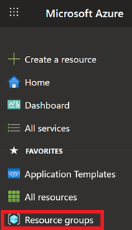
- Select the Resource Group that your preexisting Microsoft Foundry Resource resides in.
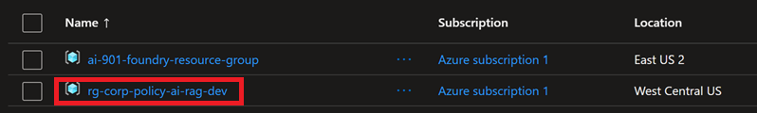

- Select your Microsoft Foundry Project resource.
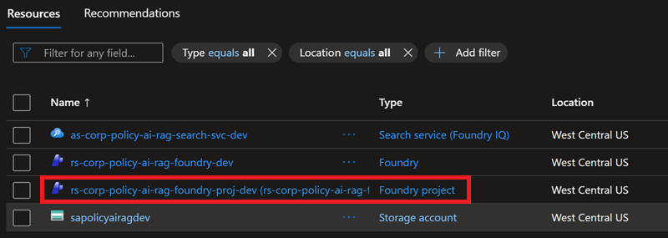

- Click Go to Foundry portal button to go to your Microsoft Foundry Project.
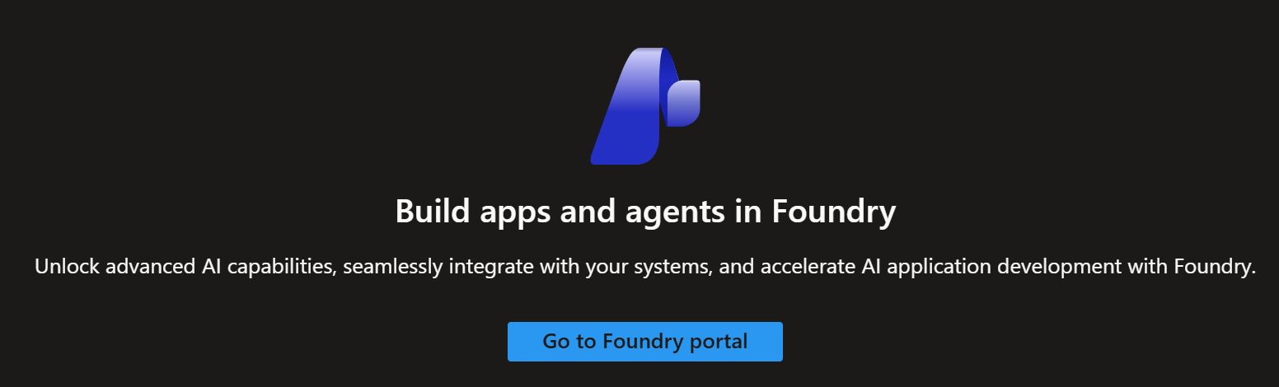
- Click the Operate menu option to go Quotas.
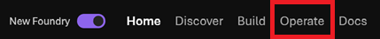
- Click Quota menu option to go Quotas.
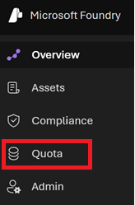

- Click the Show all toggle button to show all Models and Scopes.
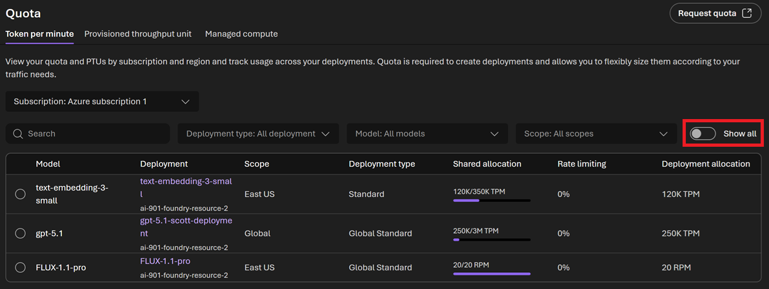
- Enter the Model or Embedding Name that you wish to search for in the Search textbox and click the Enter key.
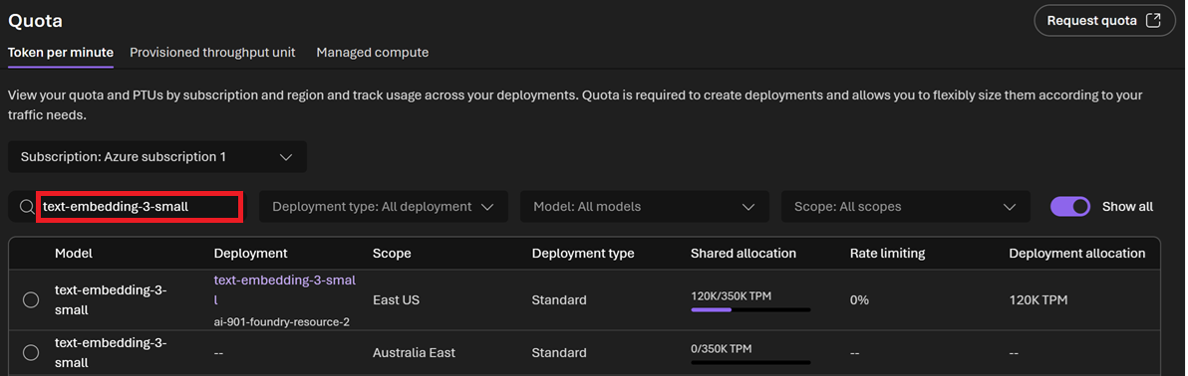

- See example Search Results for the “text-embedding-3-small” Embeddings Model.
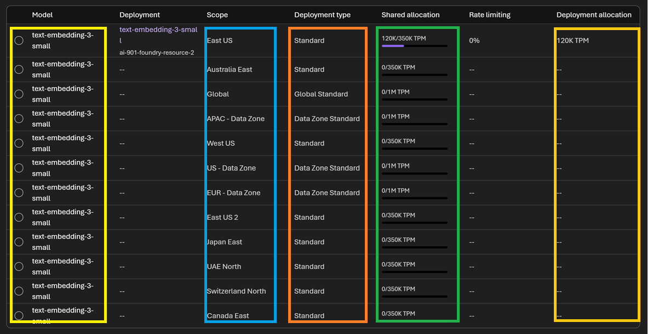
- Finished.

